No. of Pages | 3
No. of Questions | 5

Department of Computer Science and Engineering
MIDTERM EXAMINATION SPRING 2012

CSE421: Computer Network
Total Marks: 60 Time Allowed: 60 minutes
- Answer ALL FIVE (5) questions
- Figure in bracket [] next to each question indicates marks for that question

Question No. 1

- A switch maintains a table to forward frames, what kind of information does it keep in that table? How does it collect information to fill its table? [4 marks]
Z:\>arp –a
Interface: 10.253.15.72 ---0x4
Internet Address Physical Address Type
10.253.1.2 00-12-3f-ed-3f-2c dynamic
10.253.1.6 00-13-72-51-d5-a9 dynamic
10.253.1.13 00-11-4f-67-3f-c8 dynamic

Figure no. 1

- What does the output in the above Figure no. 1 represent? How does it help in our ARP process? [4 marks]
- In the CRC method, what steps does a receiver host follow with the received data and CRC bits? [4 marks]
Question 2

- Distance vector routing protocol can create routing loops, what are the ways to avoid them? Explain any two methods using an example. [8 marks]
- Distance vector routing protocol is iterative and slow to converge, explain. [4 marks]

Question 3

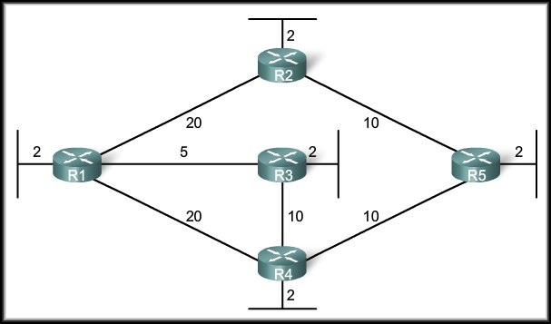
Figure no. 2

- Link state routing protocol uses Dijkstra’s algorithm. Now using Dijkstra’s algorithm, compute the shortest path from R1 to all other remote networks shown in Figure no.2. Use the table provided. [ 6 marks]
- What is the disadvantage of having a router ID in OSPF based on an active physical interface? [3 marks]
- Why should you use the bandwidth command when configuring an interface of an OSPF router? [3 marks]

Question 4

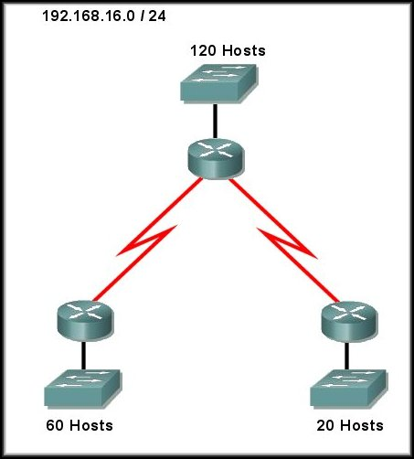
Figure no. 3

- You have been given a network address 195.168.16.0/24. But you need three sub networks for your organization and two more for the WAN Links as shown in figure no. 3. Show how you can have 5 more subnets out of the original network address as per host requirements. [8 marks]
- How does BGP avoid routing loops? [4 marks]

Question 5

- How does EIGRP support different network layer protocols? [3 marks]
- If a neighbour does not appear in the neighbour table, what should you check first for troubleshooting? [3 marks]

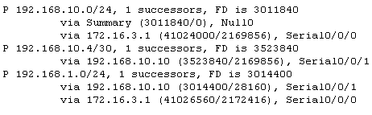
Figure no. 4

- The following output shown in Figure no. 4 was obtained from which table? What does EIGRP use to calculate the cost of the path to network 192.168.1.0/24? What do the numbers 3014400 and 28160 of 192.168.1.0/24 network imply? [6 marks]

THE END

